Procedure for joining the list of meetings with the list of attendances (phase 3 of the provided script)

Contents

Step 1: delete the 2 placehoder tables 2

Step 2: import the table “Attendance” from the file “QueryCQD_Attendance….csv” 3

Step 3: import the table “Calendar” from the file “QueryGroupCalendars_Meetings….csv” 9

Step 4: check the results 14

Step 5 (optional): export to Excel if needed 17

Step 6 (optional): import additional tables for further correlations 17

# Step 1: delete the 2 placehoder tables

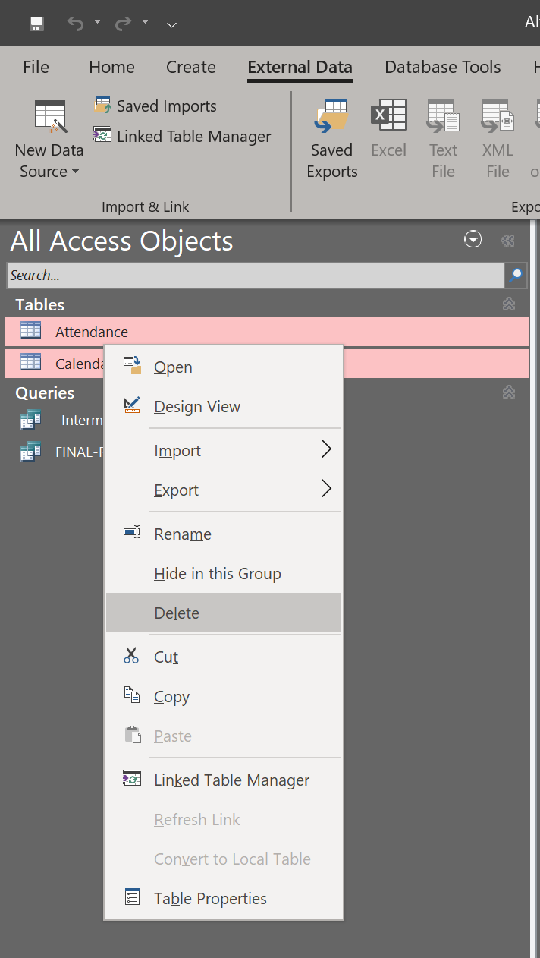

# Step 2: import the table “Attendance” from the file “QueryCQD_Attendance….csv”

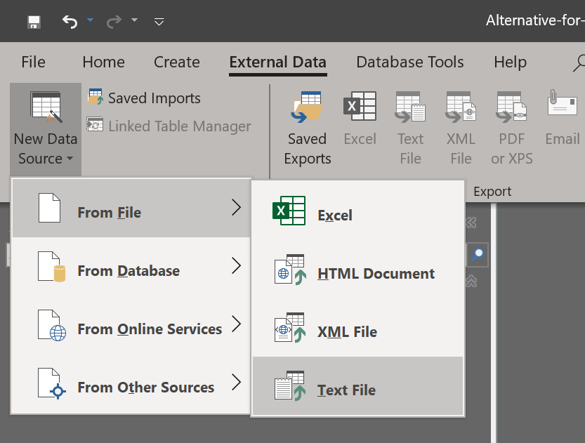

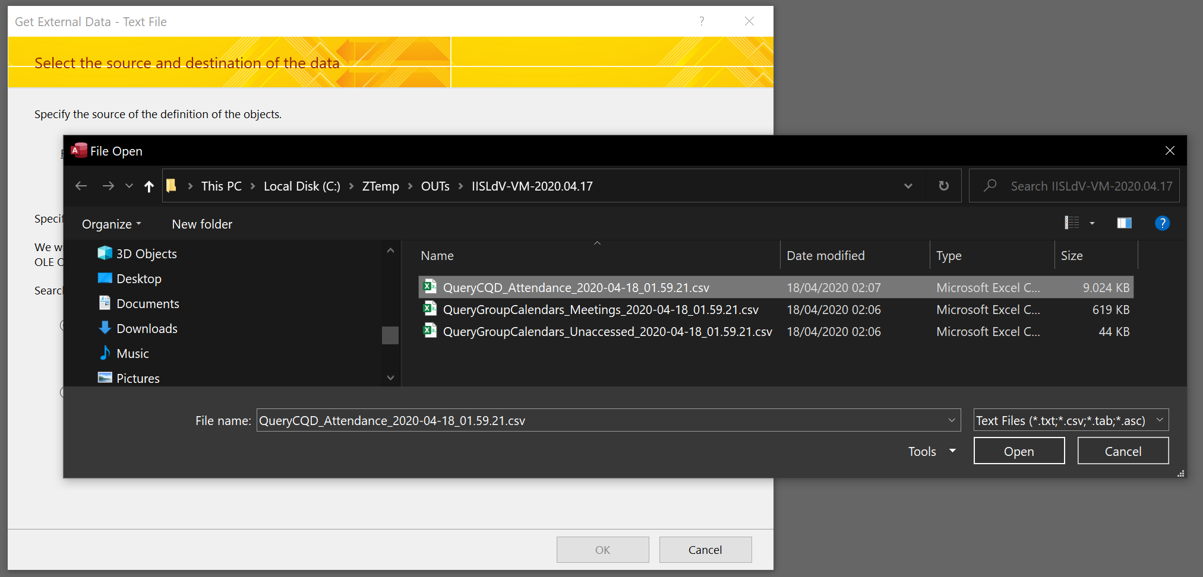

Choose:

* Field Delimiter: , (comma)
* Text Qualifier: " (double quote)
* Decimal Symbol: . (dot)

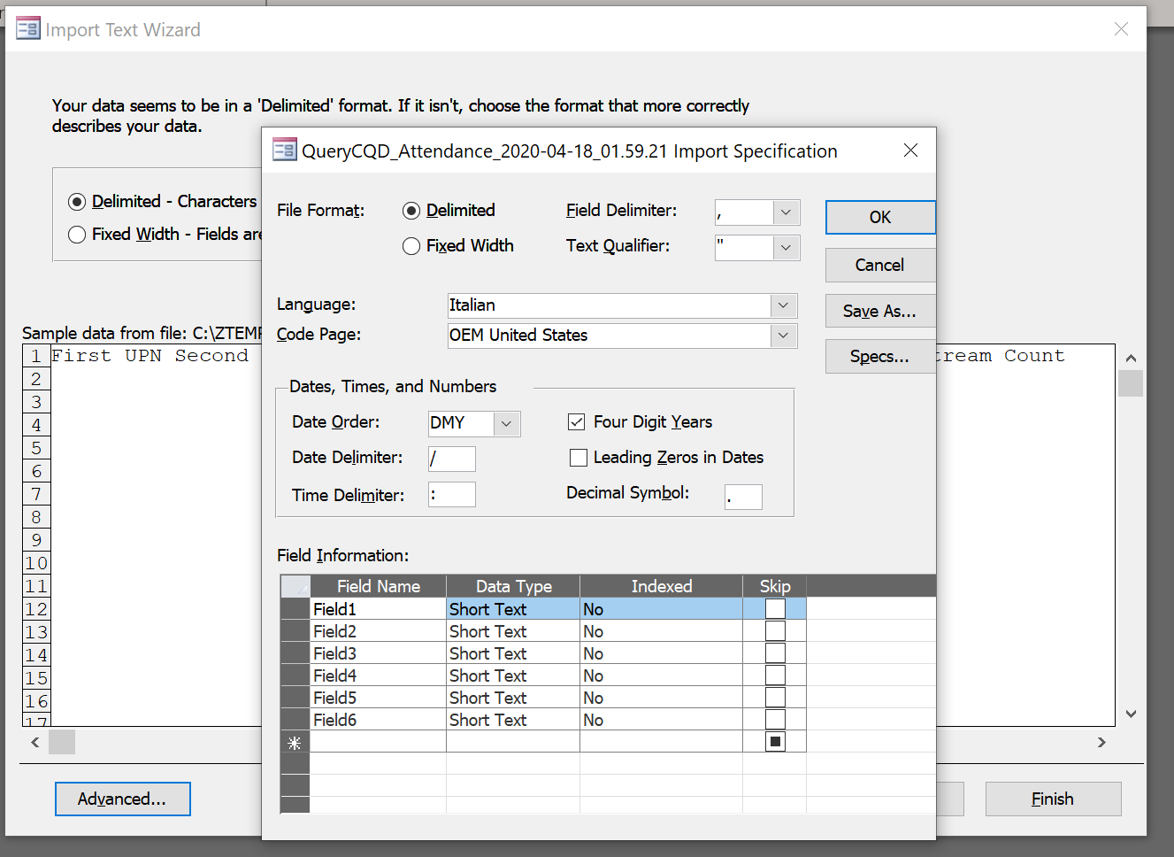

Select “First Row Contains Field Names”: 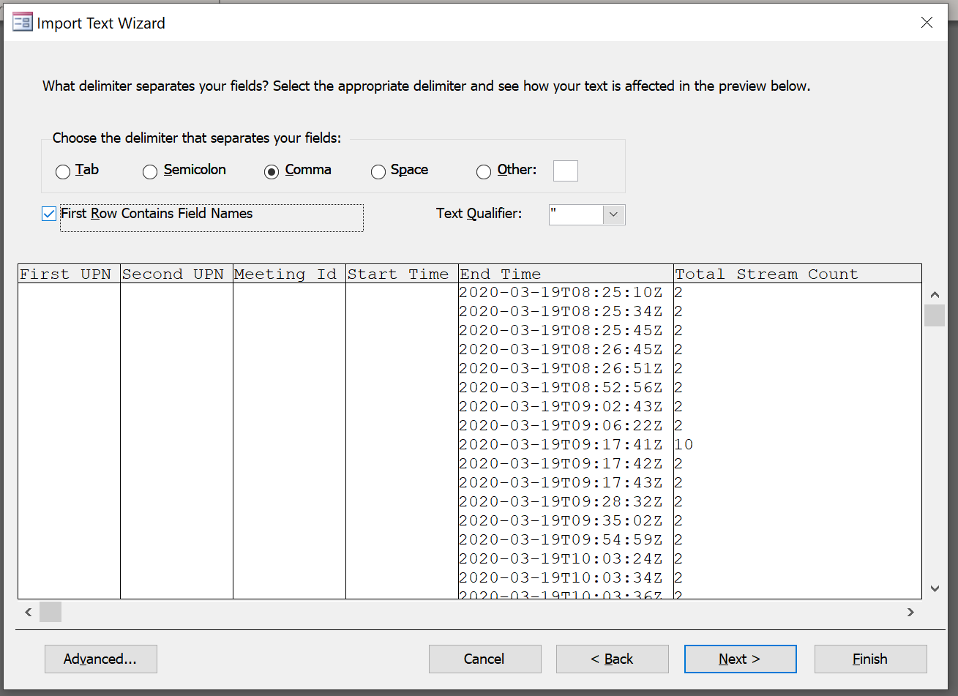

Do not change here:

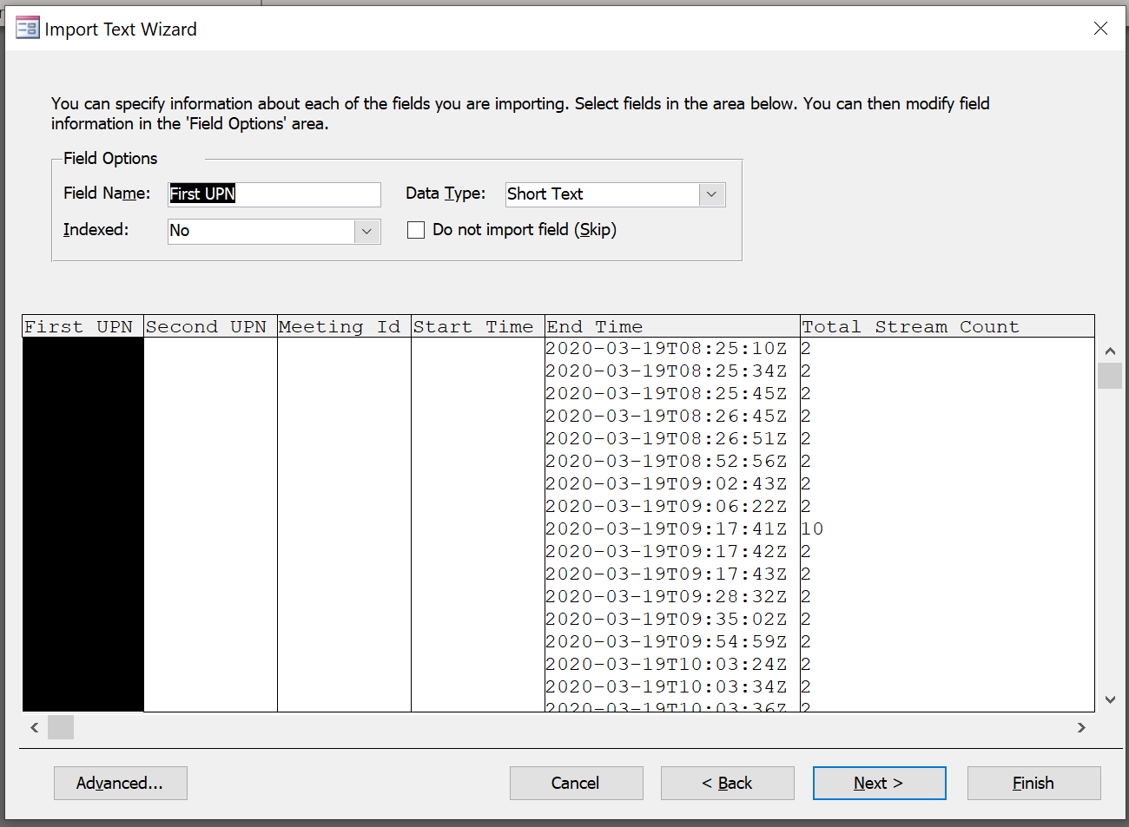

Choose “No primary key”:

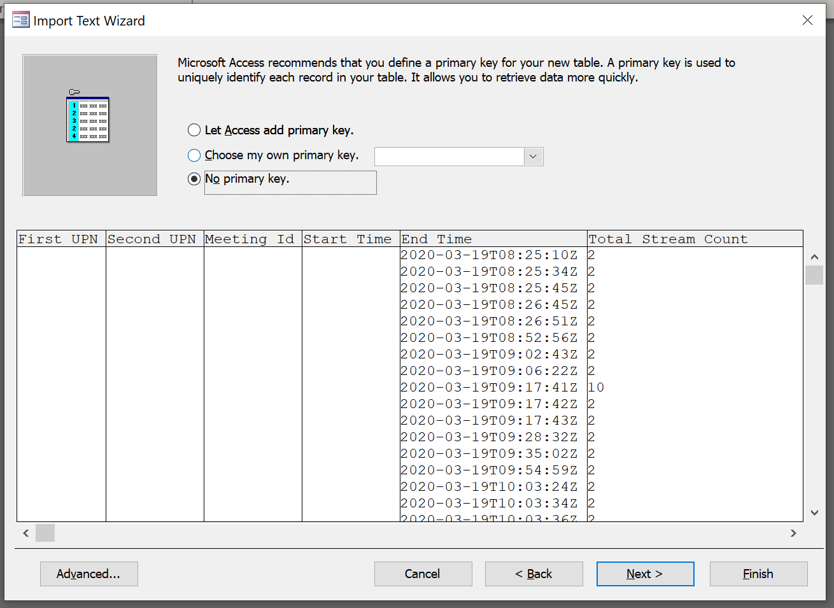

Name the table “Attendance”:

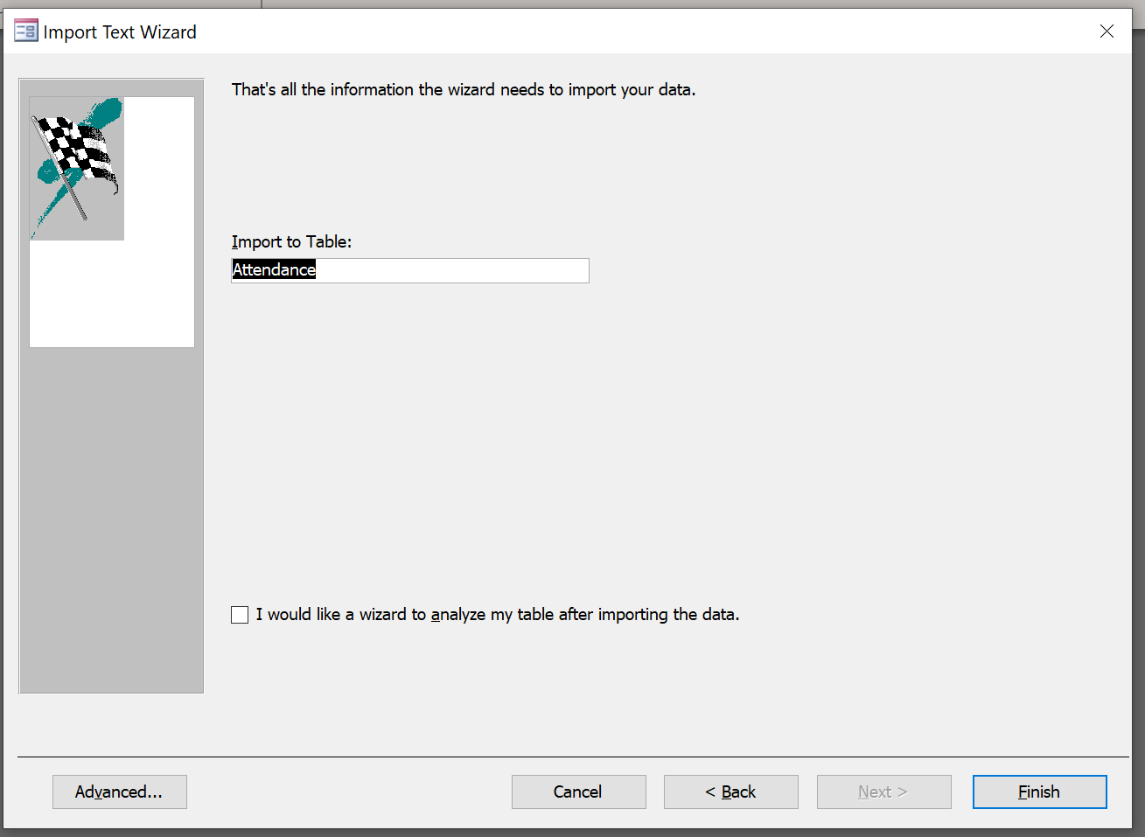

# Step 3: import the table “Calendar” from the file “QueryGroupCalendars_Meetings….csv”



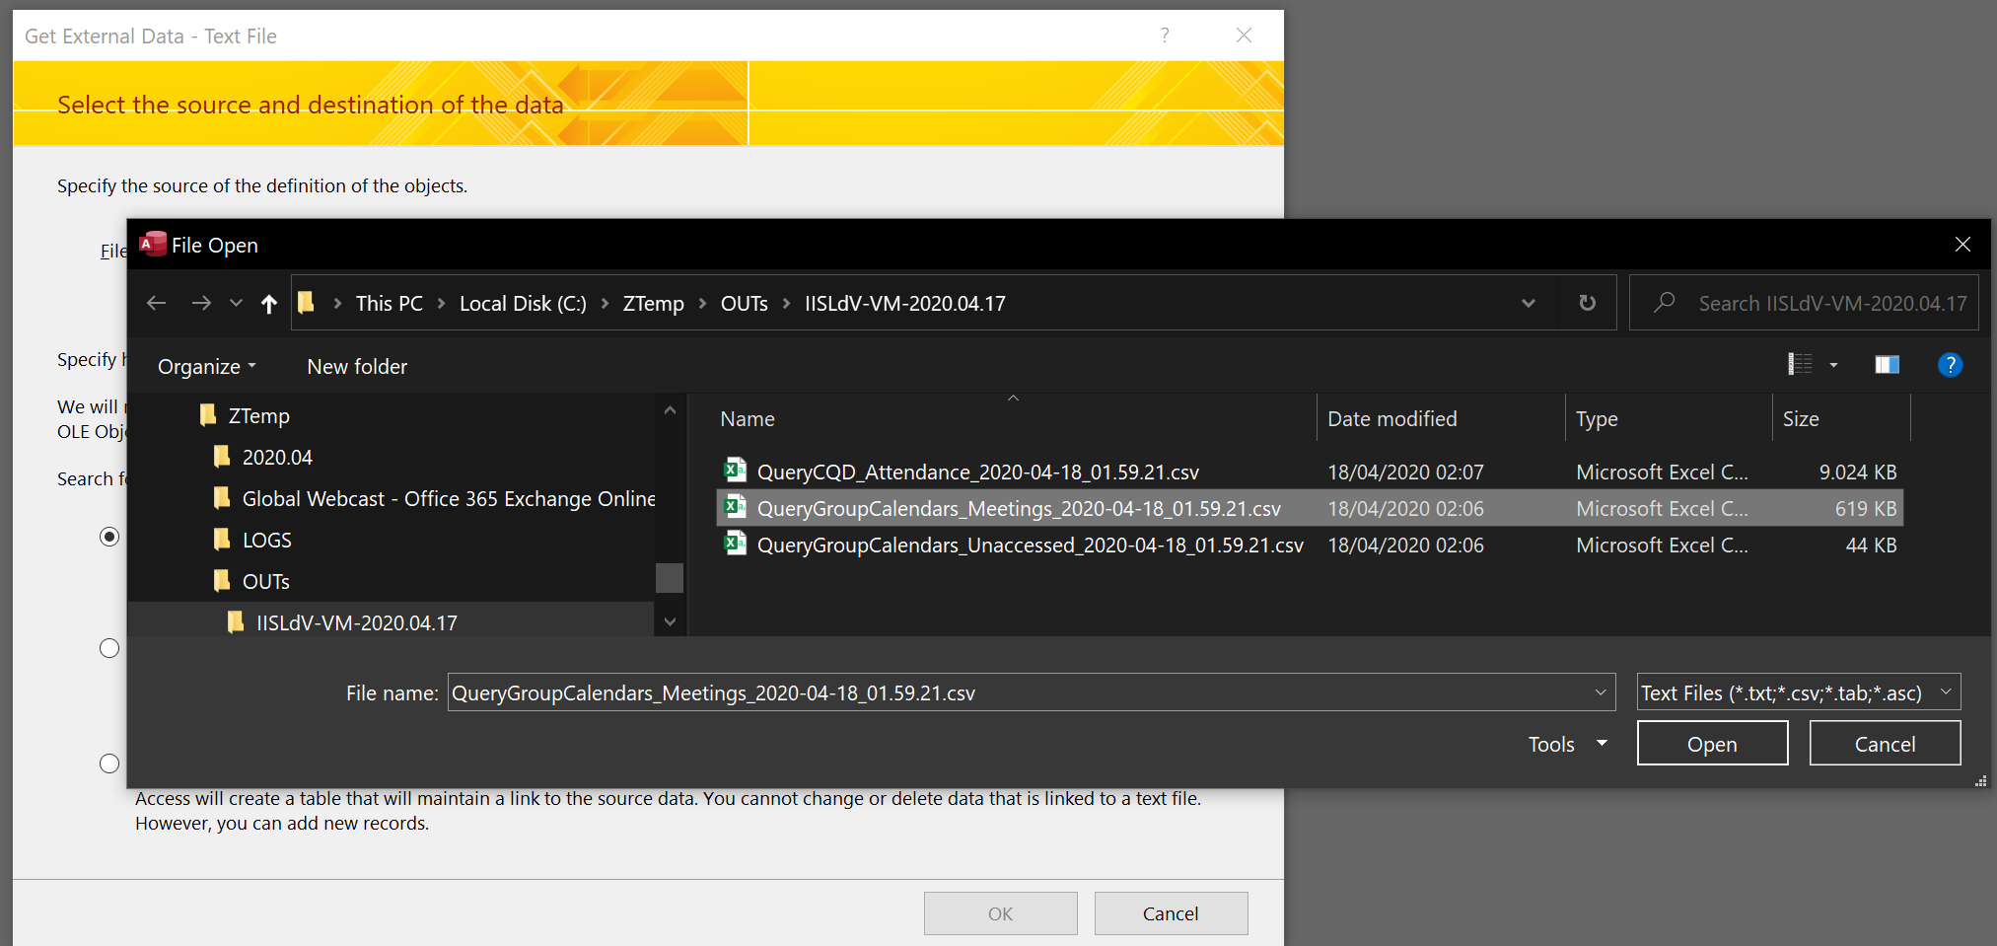

Choose:

* Field Delimiter: , (comma)
* Text Qualifier: " (double quote)
* Decimal Symbol: . (dot)

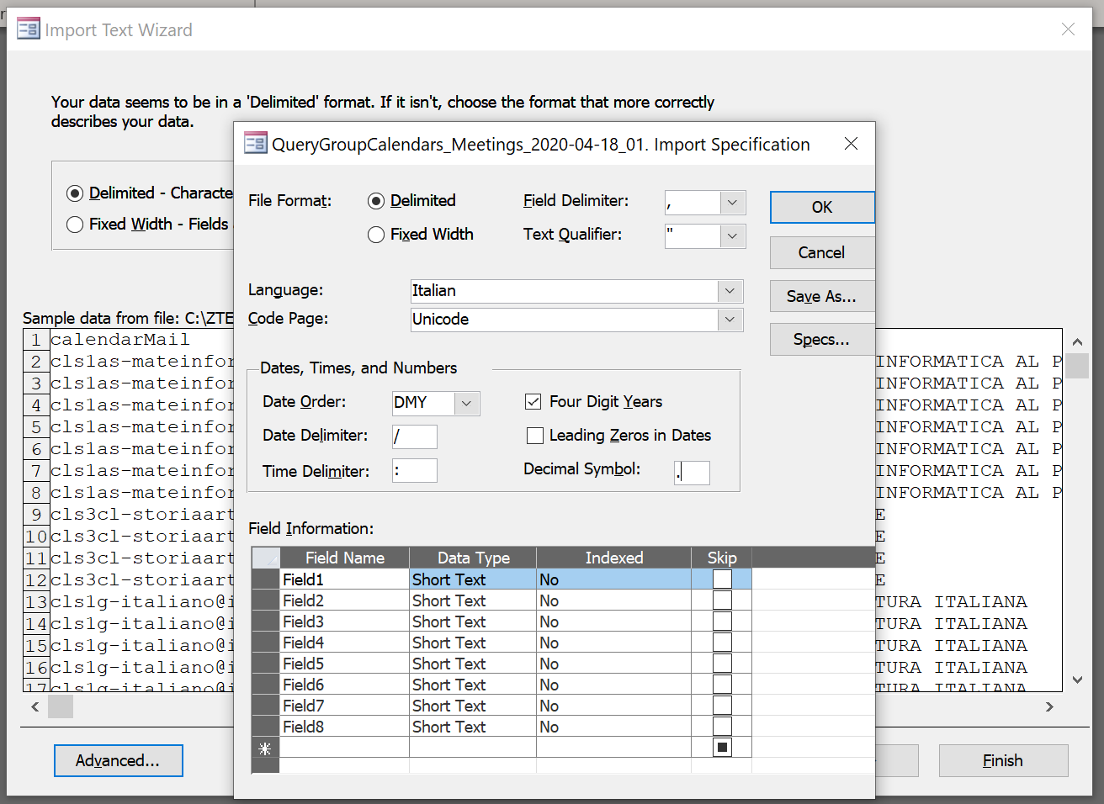

Select “First Row Contains Field Names”:

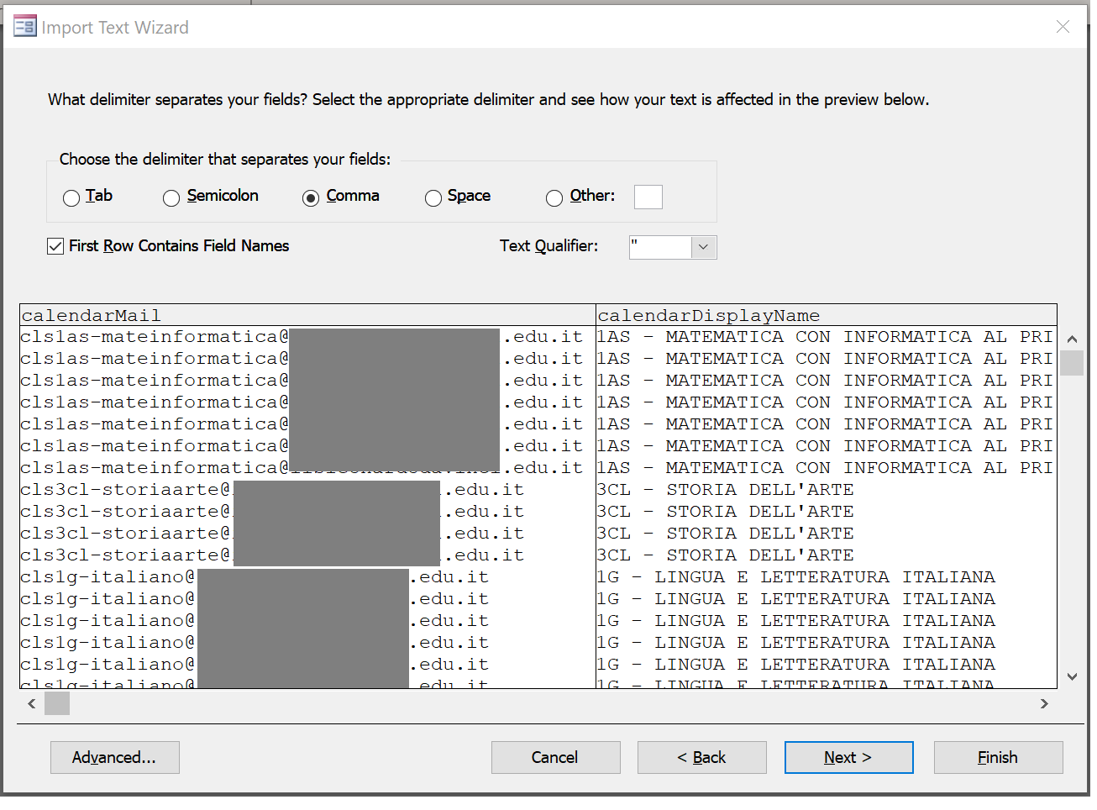

Do not change here:

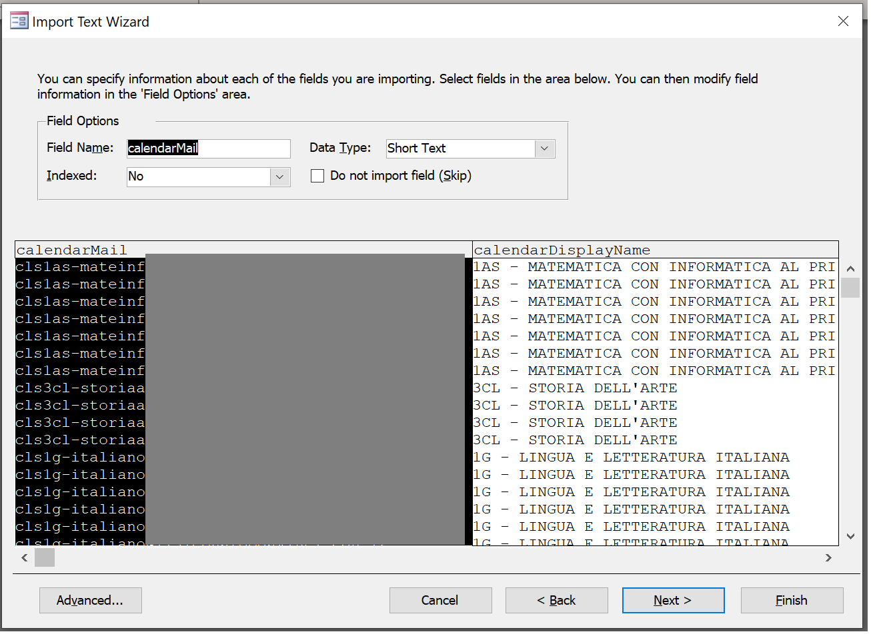

Select “No primary key”:

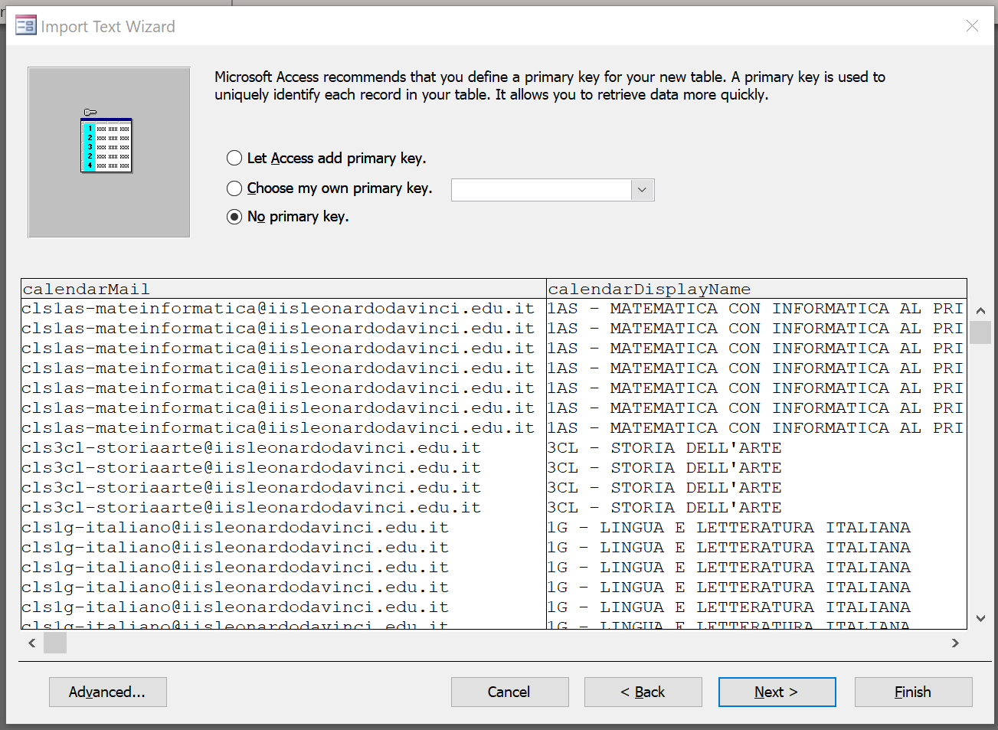

Name the table “Calendar”:

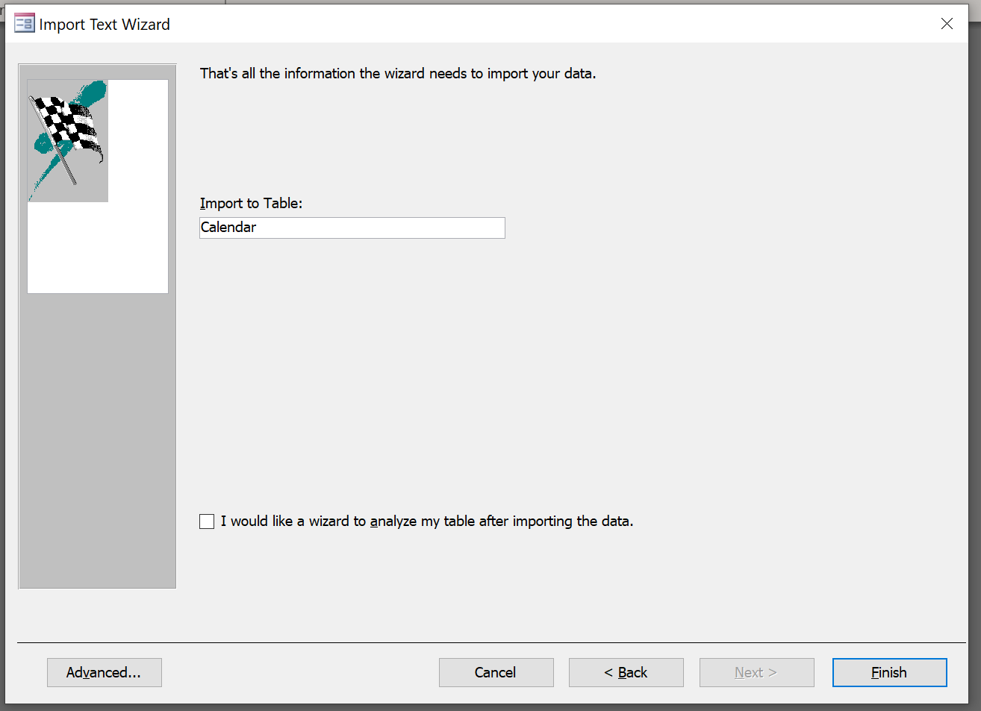

# Step 4: check the results

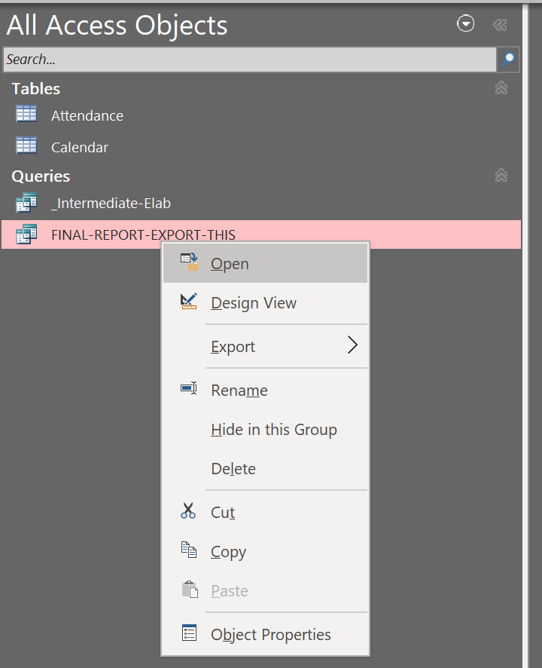

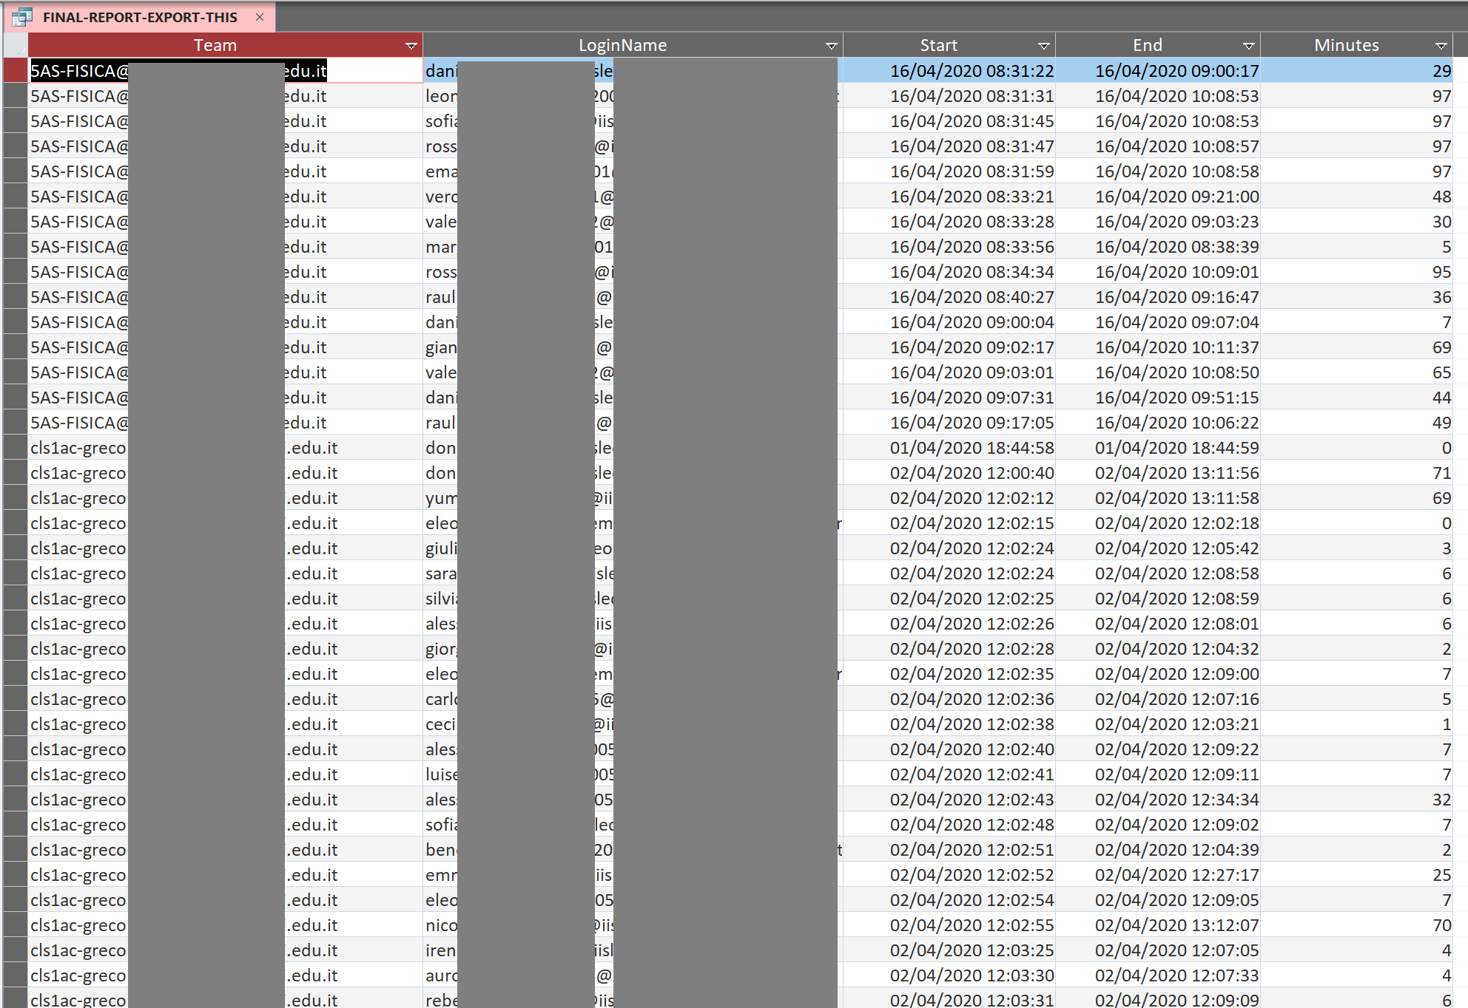

# Step 5 (optional): export to Excel if needed

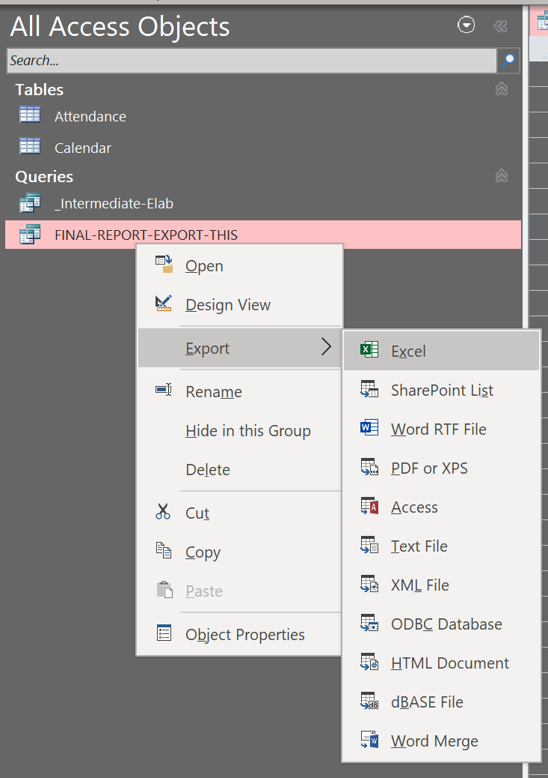

# Step 6 (optional): import additional tables for further correlations

For example, import a table with the list of the users and their role (teacher, student).

